Vale Bryan Mansfield 3/10/35 – 22/8/2024

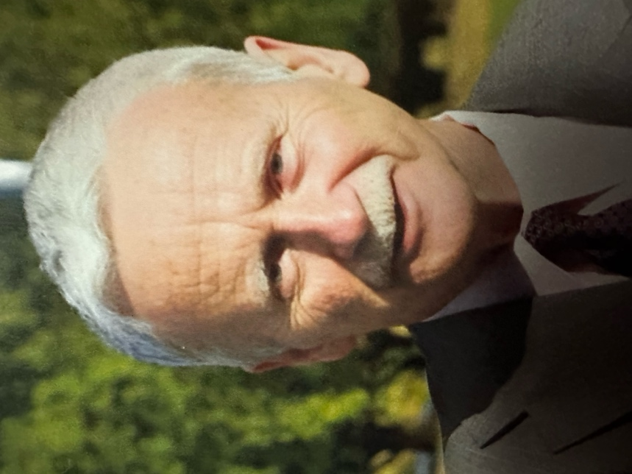

Farewell Bryan

Silently the assembled sit and wait
To farewell Bryan, a staunch, longtime mate.
Each Thursday the Sippers would meet and talk
Of joyful days among the chalk.
About forty years of teaching and principalships
In many Tasmanian schools; leadership
Of teachers, parents, especially kids.
Bryan was friendly, focused, dedicated.

He was a Rosebery lad through and through
And taught there as well, - as he wanted to do.
He was Principal of Swansea, Forest,
Yolla and Huonville, where folk would attest
That he related with school communities
By creating a sense of purposeful unity.
His warmth, care and genuine interest,
Ensured he was considered among the best!
Bryan encouraged all to tell their stories;
Took photos for his trove of memories.
His deep faith guided him along the way,
He was consistent each and every day.
He loved Jan and his family dearly,
The feelings were mutual, most clearly. –
As a very dear friend, Bryan will be missed,
No doubt, there’ll be time to reminisce!

We reflected quietly, heads all bowed,
Bryan had been “uploaded to the cloud!”

“God Bless!” ---Bryan

A memento from the Sippers Coffee Group
Writer: Bill Edmunds

Farewell Bryan

Silently the assembled sit and wait
To farewell Bryan, a staunch, longtime mate.
Each Thursday the Sippers would meet and talk
Of joyful days among the chalk.
About forty years of teaching and principalships
In many Tasmanian schools; leadership
Of teachers, parents, especially kids.
Bryan was friendly, focused, dedicated.

He was a Rosebery lad through and through
And taught there as well, - as he wanted to do.
He was Principal of Swansea, Forest,
Yolla and Huonville, where folk would attest
That he related with school communities
By creating a sense of purposeful unity.
His warmth, care and genuine interest,
Ensured he was considered among the best!

Bryan encouraged all to tell their stories;
Took photos for his trove of memories.
His deep faith guided him along the way,
He was consistent each and every day.
He loved Jan and his family dearly,
The feelings were mutual, most clearly. –
As a very dear friend, Bryan will be missed,
No doubt, there’ll be time to reminisce!

We reflected quietly, heads all bowed,
Bryan had been “uploaded to the cloud!”

“God Bless!” ---Bryan

A memento from the Sippers Coffee Group - Writer: Bill Edmunds

